ASSIGNMENT[28-01-22]:

# QUESTION 1: Regustration Form with validations:

## CODE:

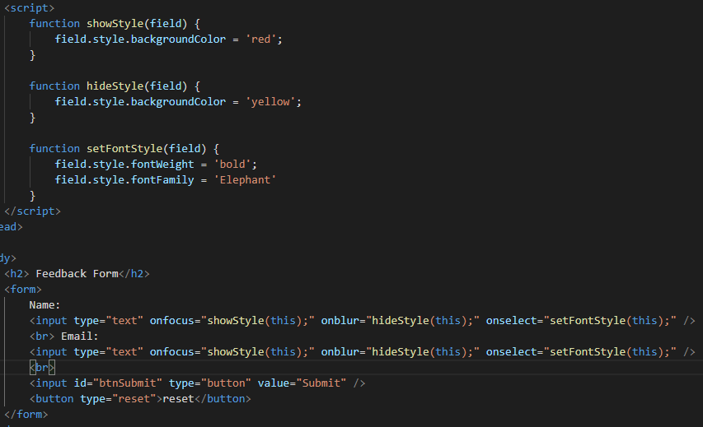

OUTPUT:

1. 2. 3.

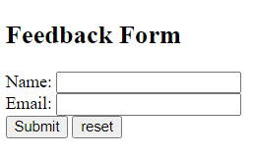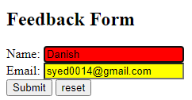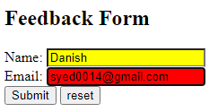

ERROR:

## QUESTION 2: Login Form with proper styling & use of jquery

## CODE:

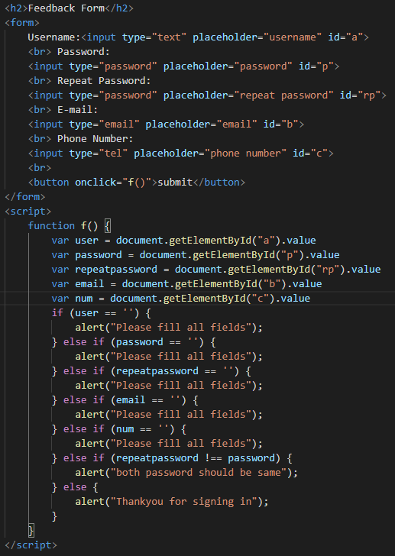

## OUTPUT:

### 1.This is Feedback Form

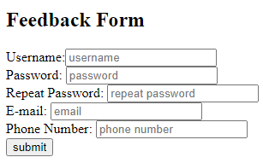

### 2.If any field remain’s empty it show’s ;

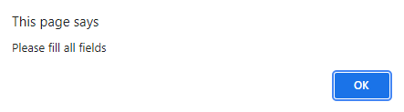

### 3.If repeat password doesn’t match to password on click of submit it show’s;

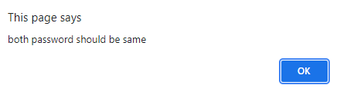

### 4.If all field are correctly & fully filled it show’s after ok all field willl be cleared;

